 20201229 Release Notes
contents
1. Change Request 2
1.1 Store order report: add total value (value * Order Quantity) 2
1.2 Daily inventory report: add category, stock value,day of inventory 3
1.3 Add need a receipt option for POS. The default value is no, and the countdown is 10S 4
1.4 Add need a receipt option for SCO. The default value is no, and the countdown is 5S 4
1.5 After the end of the day, the PC is changed from shutdown to restart. Need to meet: traffic lights work normally, TP payment system is started. 5
2. Bug Fix 5
2.1 repair the lack of member information when new registered members purchase goods 5
2.2 repair that the UN stocked report cannot be opened normally without stocktaking data 5

Change Request

Store order report: add total value (value * Order Quantity)
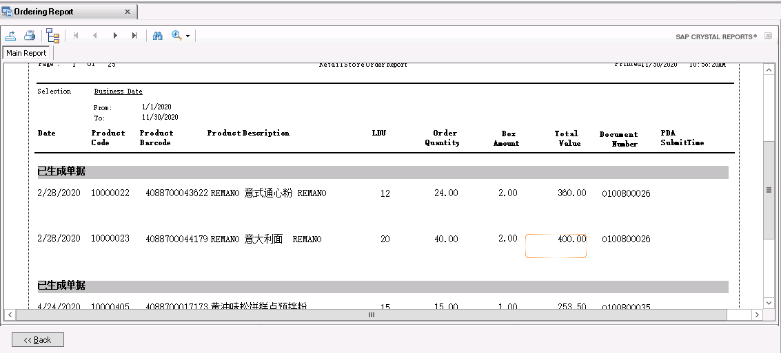

Daily inventory report: add category, stock value,day of inventory
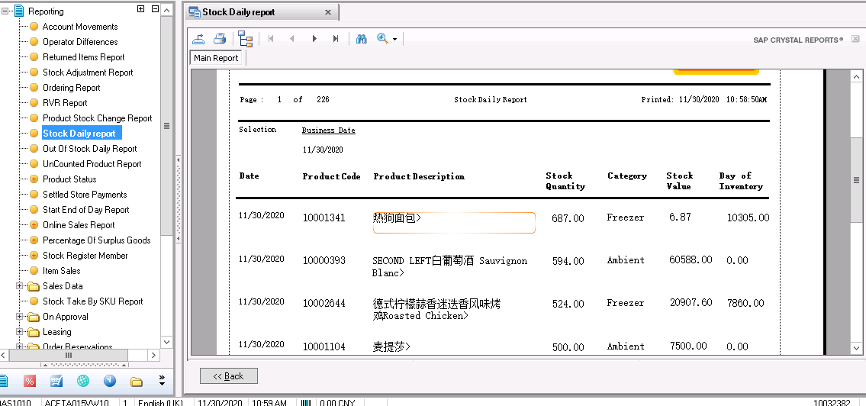

Add need a receipt option for POS. The default value is no, and the countdown is 10S
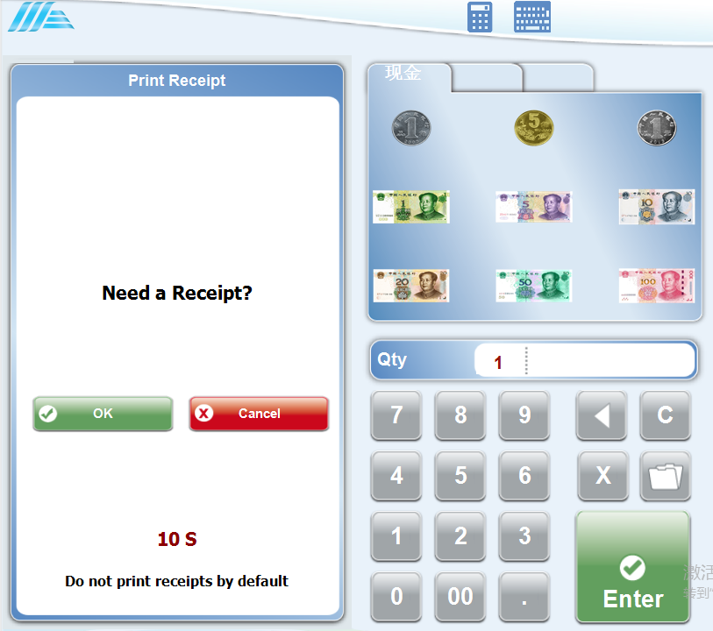

Add need a receipt option for SCO. The default value is no, and the countdown is 5S

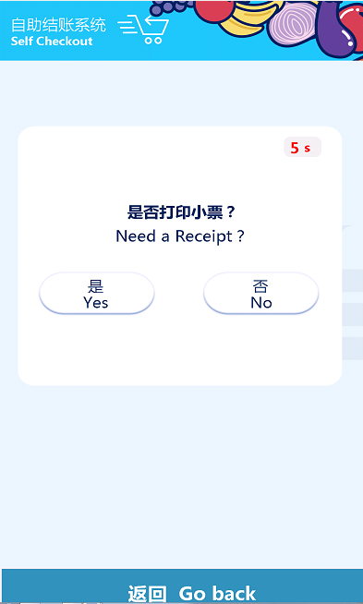

After the end of the day, the POS and Windows SCO are changed from shutdown to restart.

Bug Fix

Repair the lack of member information when new registered members purchase goods
Problem Description: buy products immediately after registering new members, and the printed ticket information has no member number or member points.

Repair that the UN stocked report cannot be opened normally without stocktaking data
Problem Description: if there is no data in the inventory data table of the database, click to view the report, and the page cannot be opened.

